**Unit 4 - Worksheet 6**

**Forces in Equilibrium**

For each of the problems below, identify the system using a system schema and then carefully draw a force diagram for the system. After you have drawn the force diagram, determine the required quantities.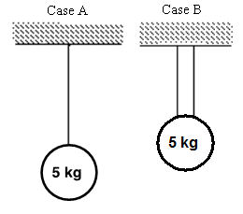

1. Determine the tension in each cable(s) in case A and case B.

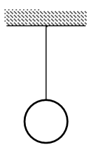

1. The tension in the cable is 100 N. Find the mass of the ball.



1. The tension in the cable on the left is 25.0 N. Find the mass of the ball.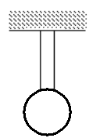
2. The block is sitting at rest on the floor. The normal force on the block is 3.00 N. Find the mass of the block.



1. A boy with a mass of 65.0 kg stands on the floor and pushes horizontally against a wall. The wall pushes on the boy with a force of 100 N. Draw a force diagram including all of the forces on the boy.



Determine:

* 1. The gravitational force on the boy by the earth.
  2. The normal force on the boy by the floor.
  3. The frictional force on the boy by the floor.

1. Determine tension in each cable. (Hint: There is more than one way to define the system.)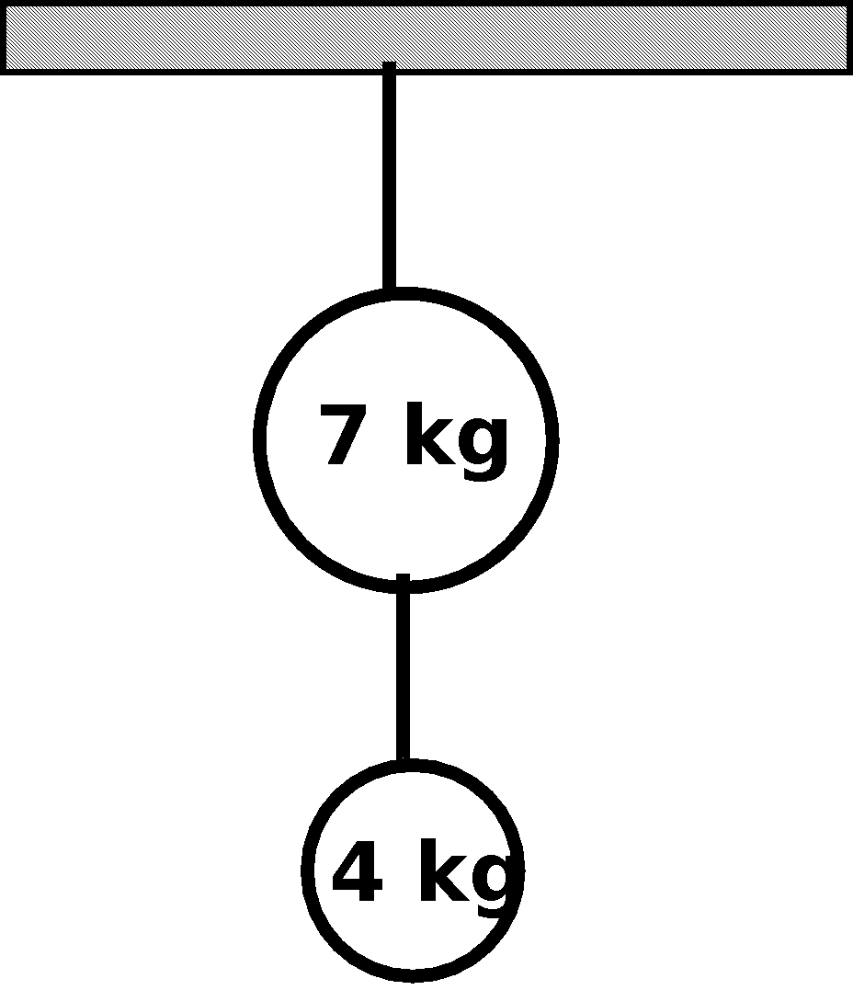
2. A person pushes on a 5.00 kg box with a force of 15.0 N to the right. As a result, the box moves at a constant speed of 10.0 m/s.

F

A by P on B

* 1. Draw the system schema for this situation.
  2. Draw the force diagram for the box.
  3. Determine the weight of the box.
  4. Determine the normal force on the box.
  5. Determine the frictional force opposing the motion of the box.